LOGIT MAIN

> GLM.1 <- glm(PersonalLoan ~ Age + CCAvg + Education + Family + Income +

+ Mortgage, family=binomial(logit), data=universal)

> summary(GLM.1)

Call:

glm(formula = PersonalLoan ~ Age + CCAvg + Education + Family +

Income + Mortgage, family = binomial(logit), data = universal)

Deviance Residuals:

Min 1Q Median 3Q Max

-2.3013 -0.2354 -0.0970 -0.0402 3.8000

Coefficients:

Estimate Std. Error z value Pr(>|z|)

(Intercept) -14.0261675 0.6189852 -22.660 < 2e-16 \*\*\*

Age 0.0120296 0.0060929 1.974 0.048342 \*

CCAvg 0.1295906 0.0363621 3.564 0.000365 \*\*\*

Education 1.6602998 0.1044471 15.896 < 2e-16 \*\*\*

Family 0.6875490 0.0688799 9.982 < 2e-16 \*\*\*

Income 0.0541232 0.0023957 22.592 < 2e-16 \*\*\*

Mortgage 0.0006305 0.0005214 1.209 0.226557

---

Signif. codes: 0 '\*\*\*' 0.001 '\*\*' 0.01 '\*' 0.05 '.' 0.1 ' ' 1

(Dispersion parameter for binomial family taken to be 1)

Null deviance: 3162.0 on 4999 degrees of freedom

Residual deviance: 1461.1 on 4993 degrees of freedom

AIC: 1475.1

Number of Fisher Scoring iterations: 7

> exp(coef(GLM.1)) # Exponentiated coefficients ("odds ratios")

(Intercept) Age CCAvg Education Family

0.0000008100519 1.0121022185699 1.1383622493367 5.2608876612237 1.9888349898668

Income Mortgage

1.0556146775315 1.0006307044747

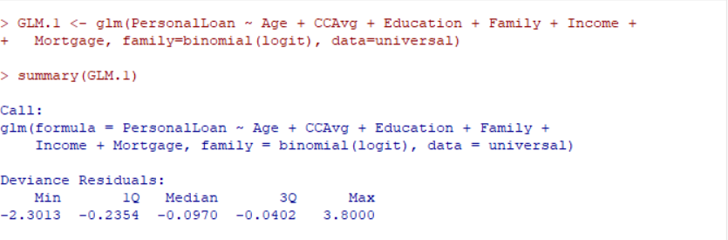

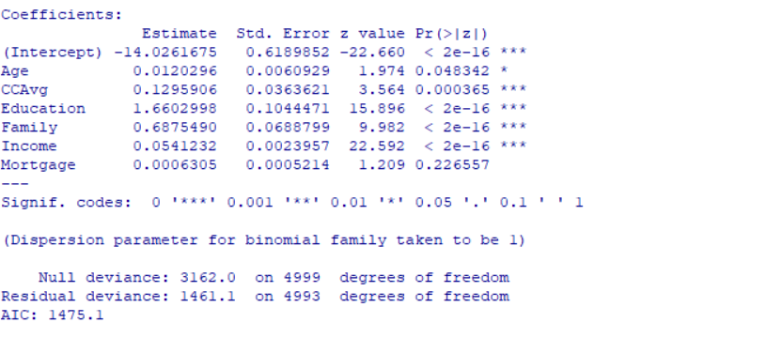

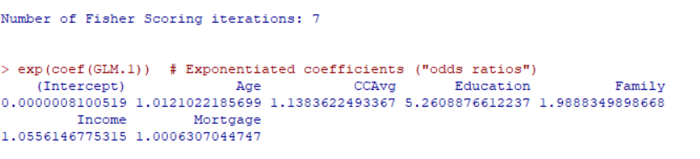

Probit main:

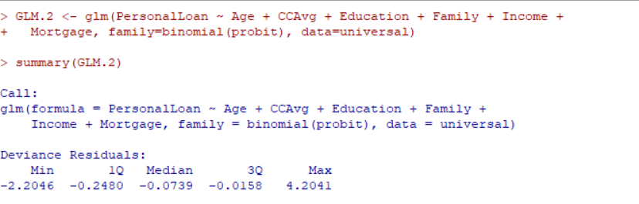

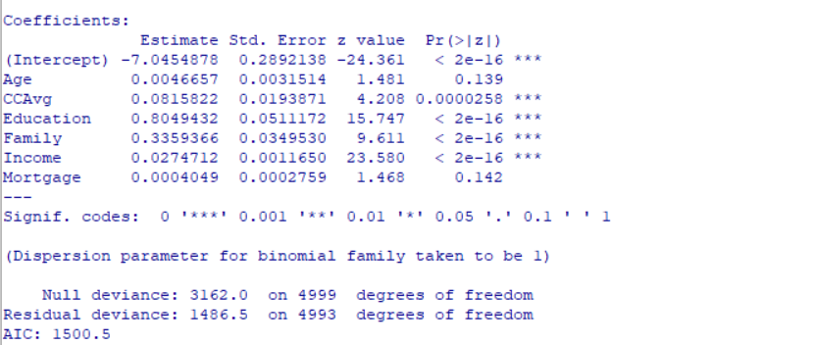



> GLM.2 <- glm(PersonalLoan ~ Age + CCAvg + Education + Family + Income +

+ Mortgage, family=binomial(probit), data=universal)

> summary(GLM.2)

Call:

glm(formula = PersonalLoan ~ Age + CCAvg + Education + Family +

Income + Mortgage, family = binomial(probit), data = universal)

Deviance Residuals:

Min 1Q Median 3Q Max

-2.2046 -0.2480 -0.0739 -0.0158 4.2041

Coefficients:

Estimate Std. Error z value Pr(>|z|)

(Intercept) -7.0454878 0.2892138 -24.361 < 2e-16 \*\*\*

Age 0.0046657 0.0031514 1.481 0.139

CCAvg 0.0815822 0.0193871 4.208 0.0000258 \*\*\*

Education 0.8049432 0.0511172 15.747 < 2e-16 \*\*\*

Family 0.3359366 0.0349530 9.611 < 2e-16 \*\*\*

Income 0.0274712 0.0011650 23.580 < 2e-16 \*\*\*

Mortgage 0.0004049 0.0002759 1.468 0.142

---

Signif. codes: 0 '\*\*\*' 0.001 '\*\*' 0.01 '\*' 0.05 '.' 0.1 ' ' 1

(Dispersion parameter for binomial family taken to be 1)

Null deviance: 3162.0 on 4999 degrees of freedom

Residual deviance: 1486.5 on 4993 degrees of freedom

AIC: 1500.5

Number of Fisher Scoring iterations: 8

Probit income \* family:

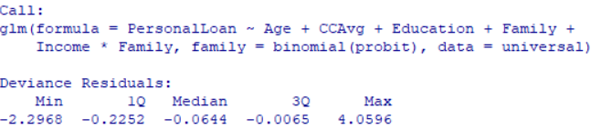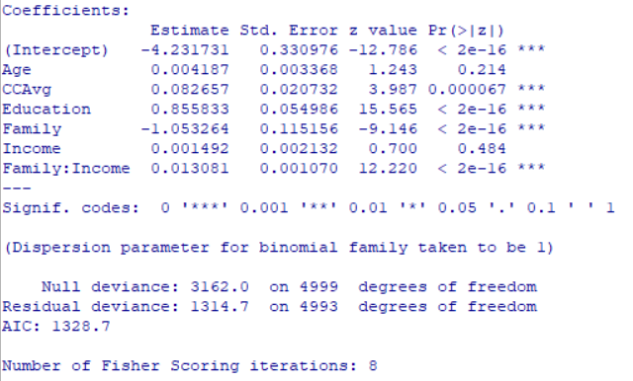

> GLM.10 <- glm(PersonalLoan ~ Age + CCAvg + Education + Family + Income\*Family,

+ family=binomial(probit), data=universal)

> summary(GLM.10)

Call:

glm(formula = PersonalLoan ~ Age + CCAvg + Education + Family +

Income \* Family, family = binomial(probit), data = universal)

Deviance Residuals:

Min 1Q Median 3Q Max

-2.2968 -0.2252 -0.0644 -0.0065 4.0596

Coefficients:

Estimate Std. Error z value Pr(>|z|)

(Intercept) -4.231731 0.330976 -12.786 < 2e-16 \*\*\*

Age 0.004187 0.003368 1.243 0.214

CCAvg 0.082657 0.020732 3.987 0.000067 \*\*\*

Education 0.855833 0.054986 15.565 < 2e-16 \*\*\*

Family -1.053264 0.115156 -9.146 < 2e-16 \*\*\*

Income 0.001492 0.002132 0.700 0.484

Family:Income 0.013081 0.001070 12.220 < 2e-16 \*\*\*

---

Signif. codes: 0 '\*\*\*' 0.001 '\*\*' 0.01 '\*' 0.05 '.' 0.1 ' ' 1

(Dispersion parameter for binomial family taken to be 1)

Null deviance: 3162.0 on 4999 degrees of freedom

Residual deviance: 1314.7 on 4993 degrees of freedom

AIC: 1328.7

Number of Fisher Scoring iterations: 8

LOGIT INCOME\*FAMILY:

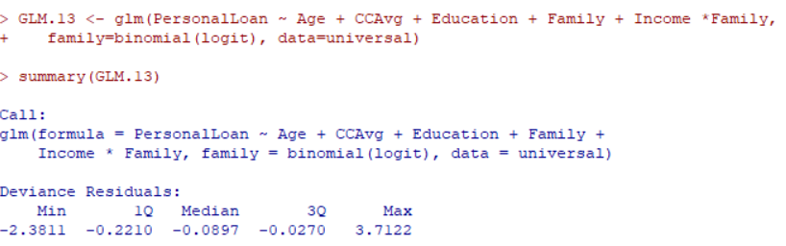

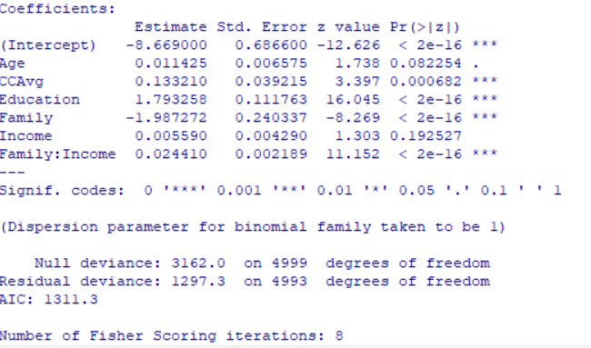

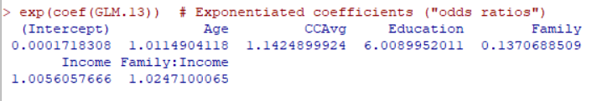

> GLM.13 <- glm(PersonalLoan ~ Age + CCAvg + Education + Family + Income \*Family,

+ family=binomial(logit), data=universal)

> summary(GLM.13)

Call:

glm(formula = PersonalLoan ~ Age + CCAvg + Education + Family +

Income \* Family, family = binomial(logit), data = universal)

Deviance Residuals:

Min 1Q Median 3Q Max

-2.3811 -0.2210 -0.0897 -0.0270 3.7122

Coefficients:

Estimate Std. Error z value Pr(>|z|)

(Intercept) -8.669000 0.686600 -12.626 < 2e-16 \*\*\*

Age 0.011425 0.006575 1.738 0.082254 .

CCAvg 0.133210 0.039215 3.397 0.000682 \*\*\*

Education 1.793258 0.111763 16.045 < 2e-16 \*\*\*

Family -1.987272 0.240337 -8.269 < 2e-16 \*\*\*

Income 0.005590 0.004290 1.303 0.192527

Family:Income 0.024410 0.002189 11.152 < 2e-16 \*\*\*

---

Signif. codes: 0 '\*\*\*' 0.001 '\*\*' 0.01 '\*' 0.05 '.' 0.1 ' ' 1

(Dispersion parameter for binomial family taken to be 1)

Null deviance: 3162.0 on 4999 degrees of freedom

Residual deviance: 1297.3 on 4993 degrees of freedom

AIC: 1311.3

Number of Fisher Scoring iterations: 8

> exp(coef(GLM.13)) # Exponentiated coefficients ("odds ratios")

(Intercept) Age CCAvg Education Family

0.0001718308 1.0114904118 1.1424899924 6.0089952011 0.1370688509

Income Family:Income

1.0056057666 1.0247100065

PROBIT INCOME \* CCAVG:

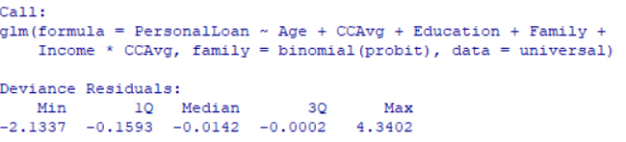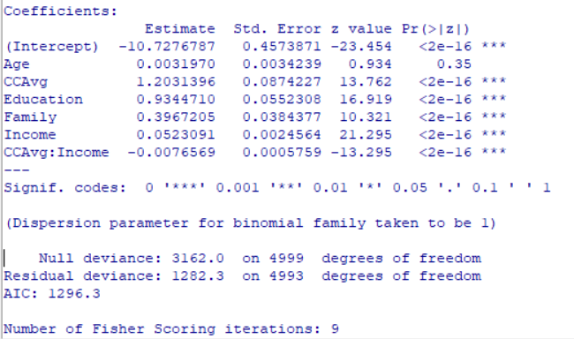

> GLM.11 <- glm(PersonalLoan ~ Age + CCAvg + Education + Family + Income \*CCAvg,

+ family=binomial(probit), data=universal)

> summary(GLM.11)

Call:

glm(formula = PersonalLoan ~ Age + CCAvg + Education + Family +

Income \* CCAvg, family = binomial(probit), data = universal)

Deviance Residuals:

Min 1Q Median 3Q Max

-2.1337 -0.1593 -0.0142 -0.0002 4.3402

Coefficients:

Estimate Std. Error z value Pr(>|z|)

(Intercept) -10.7276787 0.4573871 -23.454 <2e-16 \*\*\*

Age 0.0031970 0.0034239 0.934 0.35

CCAvg 1.2031396 0.0874227 13.762 <2e-16 \*\*\*

Education 0.9344710 0.0552308 16.919 <2e-16 \*\*\*

Family 0.3967205 0.0384377 10.321 <2e-16 \*\*\*

Income 0.0523091 0.0024564 21.295 <2e-16 \*\*\*

CCAvg:Income -0.0076569 0.0005759 -13.295 <2e-16 \*\*\*

---

Signif. codes: 0 '\*\*\*' 0.001 '\*\*' 0.01 '\*' 0.05 '.' 0.1 ' ' 1

(Dispersion parameter for binomial family taken to be 1)

Null deviance: 3162.0 on 4999 degrees of freedom

Residual deviance: 1282.3 on 4993 degrees of freedom

AIC: 1296.3

Number of Fisher Scoring iterations: 9

LOGIT INCOME\*CCAVG:

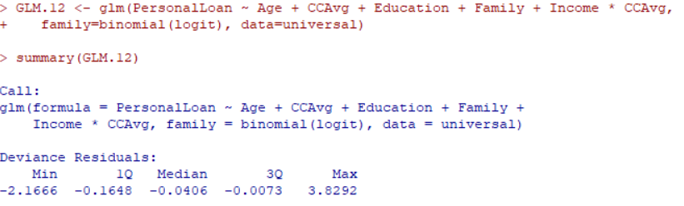

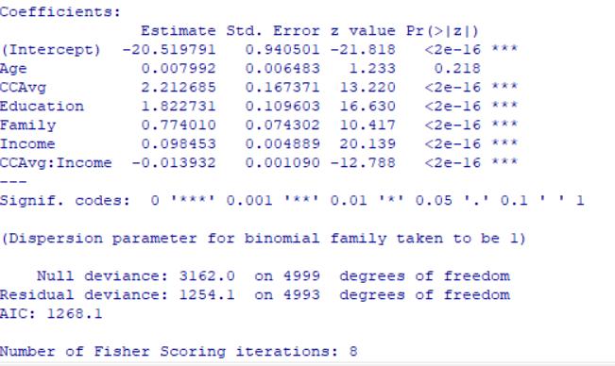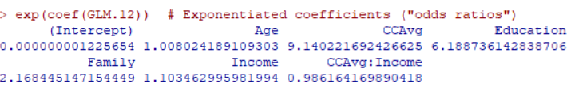

> GLM.12 <- glm(PersonalLoan ~ Age + CCAvg + Education + Family + Income \* CCAvg,

+ family=binomial(logit), data=universal)

> summary(GLM.12)

Call:

glm(formula = PersonalLoan ~ Age + CCAvg + Education + Family +

Income \* CCAvg, family = binomial(logit), data = universal)

Deviance Residuals:

Min 1Q Median 3Q Max

-2.1666 -0.1648 -0.0406 -0.0073 3.8292

Coefficients:

Estimate Std. Error z value Pr(>|z|)

(Intercept) -20.519791 0.940501 -21.818 <2e-16 \*\*\*

Age 0.007992 0.006483 1.233 0.218

CCAvg 2.212685 0.167371 13.220 <2e-16 \*\*\*

Education 1.822731 0.109603 16.630 <2e-16 \*\*\*

Family 0.774010 0.074302 10.417 <2e-16 \*\*\*

Income 0.098453 0.004889 20.139 <2e-16 \*\*\*

CCAvg:Income -0.013932 0.001090 -12.788 <2e-16 \*\*\*

---

Signif. codes: 0 '\*\*\*' 0.001 '\*\*' 0.01 '\*' 0.05 '.' 0.1 ' ' 1

(Dispersion parameter for binomial family taken to be 1)

Null deviance: 3162.0 on 4999 degrees of freedom

Residual deviance: 1254.1 on 4993 degrees of freedom

AIC: 1268.1

Number of Fisher Scoring iterations: 8

> exp(coef(GLM.12)) # Exponentiated coefficients ("odds ratios")

(Intercept) Age CCAvg Education

0.000000001225654 1.008024189109303 9.140221692426625 6.188736142838706

Family Income CCAvg:Income

2.168445147154449 1.103462995981994 0.986164169890418